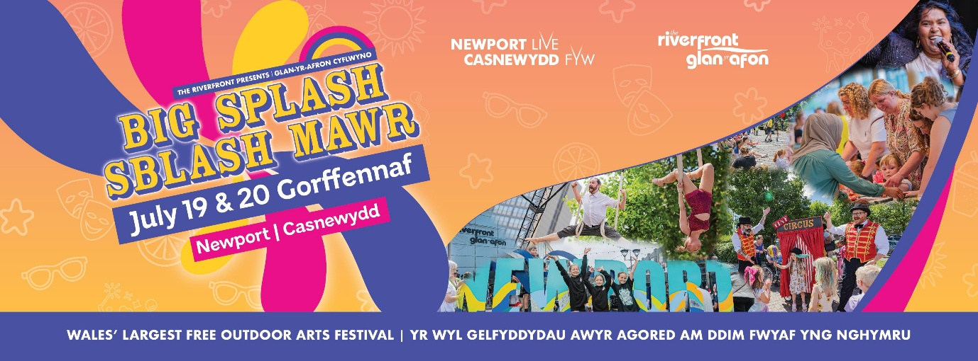

Big Splash 2025: Community Call-Out
We’re seeking creatives and community groups to join forces in creating dynamic new outdoor works that celebrate Newport’s stories, spaces, communities and cultural richness.
Through this exciting initiative, selected artists and groups will match with each other and be supported with weekly sessions to develop family friendly performances, walkabout events, or visual installations that respond to a public space, a local story, or a specific community in Newport.
This is a unique opportunity to engage in storytelling that highlights the vibrancy and diversity of our city. We aim to support at least five projects, with a focus on involving new and underrepresented communities. With guidance from experienced facilitators, participants will shape meaningful, creative experiences that bring these narratives to life.
Your application should share the stories of Newport and how your idea for outdoor arts could come to life. Community groups cover a wide range of demographics, so whether you’re a dance group, craft group, theatre troupe, music ensemble, or any other collective, we want to hear from you!
Applications close Sunday 23rd February. Once you have completed your application, please email to artsdevelopment@newportlive.co.uk.
*If your artform is to be presented live at the festival, yourself or your community group would need to be available for at least two performances on at least one day of the festival. This year's festival dates are Saturday 19th July 11am – 5pm and Sunday 20th July 12pm to 5pm.

- Tell us about yourself and your community.

- Tell us about your idea for the festival and what artform you would present that through.

- How would you benefit from working with an arts facilitator?

- How many participants are in your group?

- Why do you think festivals like Big Splash are important?

- Will your community be available to present your work over the festival weekend? (Saturday 19 and Sunday 20 July)

- Who would you like to reach with your artform?

- Do you have any access requirements?

- Does your group meet regularly? Do you have a space that you utilise regularly, or would you prefer to be provided with a space for this process?

