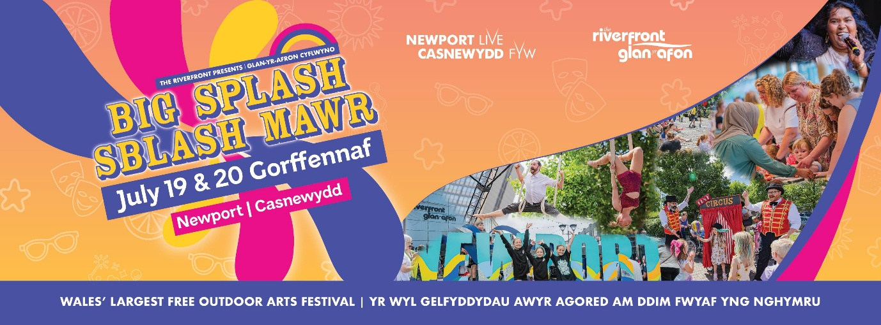

Big Splash 2025: Facilitator Call-Out
We’re seeking creatives and community groups to join forces in creating dynamic new outdoor works that celebrate Newport’s stories, spaces, communities and cultural richness.
Through this exciting initiative, selected artists and groups will match with each other and be supported with weekly sessions to develop family friendly performances, walkabout events, or visual installations that respond to a public space, a local story, or a specific community in Newport.
This is a unique opportunity to engage in storytelling that highlights the vibrancy and diversity of our city. We aim to support at least five projects, with a focus on involving new and underrepresented communities. With guidance from experienced facilitators, participants will shape meaningful, creative experiences that bring these narratives to life.
We want to hear your stories and what you believe will create an impact piece of outdoor arts to present at this year's Big Splash festival.
Your application should tell us about your background in the arts and why you love outdoor arts specifically. It should cover your artforms and any proposed costs for your time and any materials that you might use in facilitating community groups bringing their stories to life.
Applications close Sunday 23rd February. Once you have completed your application, please email to artsdevelopment@newportlive.co.uk.

- Tell us about yourself and your relationship with outdoor arts.

- Give us an overview of your work and the artforms you utilise.

- How do you bring the best out in the participants that you are working with?

- Can you give us an overview of your facilitation costs?

- Which days of the week are you best suited to facilitate?

- Do you carry any specific training that supports your work?

- Do you have Public Liability Insurance and have a current DBS?

